You are a Senior Spring Boot Architect, Technical Trainer, and LinkedIn Tech Content Strategist.

I am running a 100-day deep Spring Boot + Java backend preparation series for interview readiness and real-world engineering mastery.

Today’s Topic:
Day 17 : Mastering Spring Profiles &Environment Config
Mastering Spring Profiles : Annotations and Practical Examples

Assume that u are subject matter expert for Spring + Spring Boot , teaching spring boot for student who is beginner but end of this day he should be perfect and clear end to end in this topic.
Mastering Spring Profiles : Annotations and Practical Examples
- What is Profiling
- How to Use
- @Profile Annotation
Let’s take a scenario we have DBConnection Component and it has fields that get’s values form Properties file with @Value annotation and @PostConstruct method prints those values and startup file injects beans as this DBConnection is a component will get injected by Spring Container and will print the credentials and each time we change the values that prints profile specific credentials

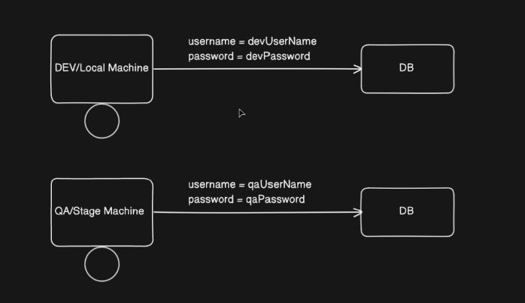
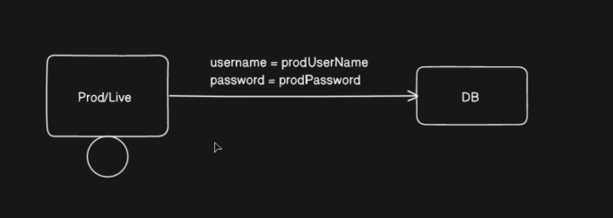
For Dev,UAT,Prod we need different Username and password for DB Connection or many other usecases, other than these username password we might have several other configurations which are different for different environments we store these configurations in application.properties
Ex: Port,URL,Connnection Timeout Values,Retry count etc.
How to do it?
- if we want to use the same application properties we might require to change the details each time for each environment
- we need to add configuration in application.properties file
- but how to handle different config for different environments

We can create different application properties profiles for different profiles
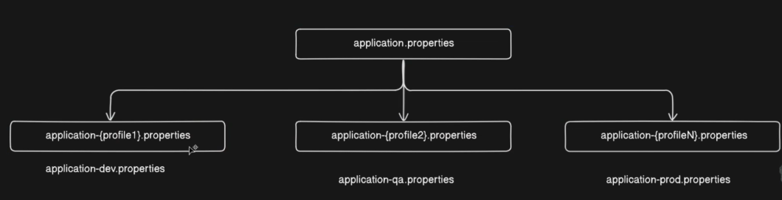

How to set profiles?
At application startup we can tell spring to pick specific application.properties file
Using spring.profiles.active configuration

Let’s create three configuration properties files i.e
- application-dev.properties
- application-qa.properties
- application-prod.properties

with different credentials or configurations and in main application.properties we add spring.profiles.active = dev
and if we run then that dev profile will be selected and runs dev properties and prints same works if we change to qa and prod
Explain with code snippets of properties files and outputs and code and explain why and how it’s working also mention how frequently developer has to modify the main file for maintaining the profile based configuration.

And what if mention spring.profiles.active = prod
And prod specific properties file is missing then it fetches from parent properties files
Explain the hierarchy with cases and code snippets.

But we don’t want to specify this inside the application rather we want to externalize the config selection from outside.

How to configure profile config dynamically
2 ways
- while application startup using command
  - mvn-spring-boot:run-Dspring-boot.run.profiles=prod
- Add profile in pom.xml
  - Add run using mvn-spring-boot:run-Pproduction
With this profiling ends
@Profile Annotation
Using @Profile annotation we can tell springboot to create a bean only when a particular profile is set

This explain with @Profile annotation used in components with different profile set all cases with code snippets and outputs and snapshots of properties files as well.
We can take example
- DBConnection
- MySQLConnection
- NoSQLConnection
With @Value() to fetch the username and password and some credentials specific to a profile and print with constructor to visualize the behaviour
Three beans @Component annotations I want all cases with profiling and @Profile annotation with different values with Prod as profile and with @Profile annotation with “Dev” in one component and “Prod” in another component all injecting bean cases and non injecting bean cases like with profile annotation set with all possible case values and without profile annotation
With code snippets and properties snapshots

Also want to see how it behaves if we put like this spring.profiles.active = prod,dev
Multiple profiles if we set active? It will pick which is at the end like dev is at the end now
how it behaves if we put like this spring.profiles.active = prod,qa
Multiple profiles if we set active? It will pick which is at the end like qa is at the end now

Mandatory note : Include all content and cases separate code snippets of both beans and starter app and application properties snapshot of code for all cases and must important thing for each case explain the scenario first and separate code snippets and code and explanation and output and how it behaves.

Must Use the above content and need all the content mentioned above also take the suggestions below

I want TWO outputs:
========================================
PART 1 — LINKEDIN POST (High Reach Version)
========================================

Write a short, crisp, high-engagement LinkedIn post that:
• Uses a real-life analogy or scenario (like Mani & Mini, office workflow, friends, team conflicts, etc.)
• The analogy must map clearly to the Spring concept
• The story should be funny, relatable, and memorable
• Use real Spring terminology inside the story (Bean, IoC, Container, Configuration, Dependency, etc.)
• Create curiosity in the first 2 lines (strong hook)
• Make people WANT to read the document
• End with a call-to-action: Save | Follow | Comment | Read
• Keep it short enough for daily posting (not long blog style)

Include:
• Emojis (but not excessive)
• 1--15 relevant hashtags (#SpringBoot #Java #Backend #Interviews #100DaysOfCode etc.)
• A powerful ender line

Do NOT include code in the LinkedIn post.

========================================
PART 2 — MASTER TECHNICAL DOCUMENT
========================================

Write a **go-to reference document** for this topic.

This document must be:
• Extremely clear
• Interview-grade
• Real-world engineering grade
• Step-by-step
• Code-heavy where needed
• Properly structured
• Easy to revise before interviews

The document must include:

1️⃣ **Concept Foundation**
• Why this concept exists
• What problem it solves
• Where it fits in Spring Boot architecture

2️⃣ **Core Definitions**
• Define all key annotations and terms involved
• (@Component, @Configuration, @Bean, Auto-config, BeanFactory, ApplicationContext, etc.)

3️⃣ **How Spring Actually Executes This**
• Startup flow
• Which annotation is read first
• How Spring decides what to create
• What happens internally

4️⃣ **Code Examples**
• Minimal example
• Real-world style example
• Show both correct and problematic cases
• Show how Spring behaves in each

5️⃣ **Differences Table**
• Compare related annotations (e.g. @Component vs @Configuration, @Bean vs @Component, etc.)

6️⃣ **Hidden Traps**
• Circular dependency risks
• Proxy behavior
• Bean duplication
• Startup failures
• Why things work in Boot but not in Core Spring

7️⃣ **Interview Angle**
• Why interviewers ask this
• What they actually want to test
• Common wrong answers
• Correct framing

8️⃣ **Most Asked Interview Questions (with Answers)**
• 10–15 high-quality questions
• Mix of theory + scenario + code based
• Answers must be short, crisp, and technically correct

9️⃣ **One-page Mental Model Summary**
• How to remember this topic in real projects

10️⃣ **End Section**
• Key takeaways
• Why this topic matters in enterprise systems
• How it connects to future topics (Boot, Auto-config, AOP, Security, etc.)

========================================

Style Rules:
• Do NOT be dry
• Be clear, authoritative, and professional
• Avoid textbook tone
• Use real-world language
• Assume reader is preparing for backend interviews
• No fluff, only high-signal content

End of the document should have Summary as A Story :
From start to end of the spring Boot Application where we write this and how spring boot uses this or flow of events happening including this part.
This document should feel like:
"The one PDF a serious Spring Boot backend engineer would keep before interviews."

Start with the topic title as a heading.
End the document with a divider line and a “Follow & Save for the next topic” call-to-action.

